Design Sheet 1:   
  
Map showing hotspots of commonly visited tourist spots

Chloropleth showing proportion of tourism by population in Australia

Category Visuals:

Bar represents state, proportions for each bar like image

Select state, then returns horizontal bar graph of categories

Histogram of categories for all Australia

Dot Plot where y-axis is category, x-axis is state dot for most common category

Fastest growing state visual:

Line graph, one for each state showing change in number of trips from 2010-2016

Bump chart that ranks each state based on growth rate for each year

Lollipop chart where circle represents population filtered by year, ranks fastest growing based on height

Best visited Regions visual:

Horizontal bar chart

Table

Treemap

Quarter-by-Quarter calendar visual:

Select year given calendar heat map for year by quarter

Donut chart where each slice represents quarter -> proportion of tourism

Line graph where each line represents quarter showing trend

**Filter Out:** Hotspot Map, Histogram of Categories, Lollipop Chart, Donut Chart, Treemap

Sheet 2:

Map, select state return category distribution, bump chart, table, calendar heat map

Sheet 3:

Map, dot pot, line graph for fastest growing, horizontal bar chart for best visited regions, heat map

Sheet 4: Map, image bar graph, bump chart, horizontal bar chart for best visited regions, calendar heat map

Sheet 5: Sheet 4 design with greater focus   
  
  
Data Visualisation 2 Proposal

Chloropleth map that shows proportion of tourism by population in Australia

* See if you can filter by year

Horizontal bar graph Like one below where each bar represents state, and legend refers to category, measure is number of visits for specific category do it for total, do not filter by year

<https://gist.github.com/pratapvardhan/00800a4981d43a84efdba0c4cf8ee2e1>

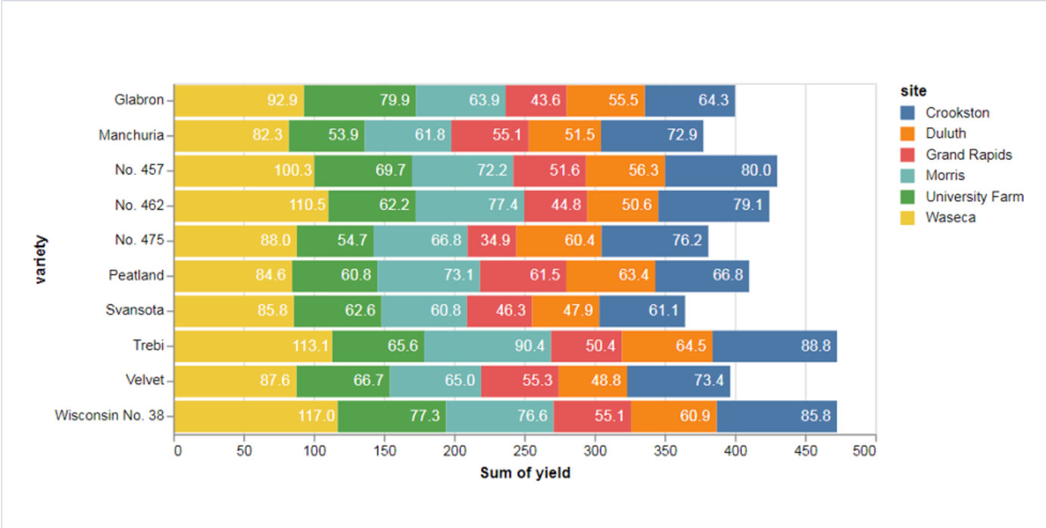

Visual that ranks based on fastest growing in terms of tourism -> Highest growth rate is used as measure

Visual that has a slicer that lets you pick a state and year, and returns top 5 most visited regions

Visual showing off-season on season by quarter for Australia as a whole since 2010